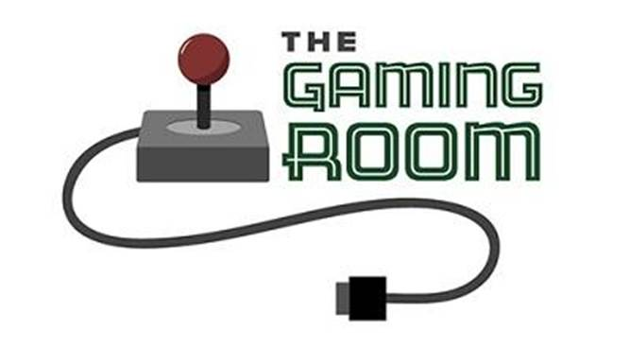

<Name-of-Software-Application>

CS 230 Project Software Design Template
Version 1.0

Table of Contents

CS 230 Project Software Design Template 1
Table of Contents 2
Document Revision History 2
Executive Summary 3
Requirements 3
Design Constraints 3
System Architecture View 3
Domain Model 3
Evaluation 4
Recommendations 5

Document Revision History

Version | Date | Author | Comments
1.0 | 10/3/2026 | Aaron Strowbridge jr

Instructions
Fill in all bracketed information on page one (the cover page), in the Document Revision History table, and below each header. Under each header, remove the bracketed prompt and write your own paragraph response covering the indicated information.

Executive Summary

<Write a summary to introduce the software design problem and present a solution. Be sure to provide the client with any critical information they must know in order to proceed with the process you are proposing.>

Requirements

< Please note: While this section is not being assessed, it will support your outline of the design constraints below. In your summary, identify each of the client’s business and technical requirements in a clear and concise manner.>

Design Constraints

<Identify the design constraints for developing the game application in a web-based distributed environment and explain the implications of the design constraints on application development.>

System Architecture View

Please note: There is nothing required here for these projects, but this section serves as a reminder that describing the system and subsystem architecture present in the application, including physical components or tiers, may be required for other projects. A logical topology of the communication and storage aspects is also necessary to understand the overall architecture and should be provided.

Domain Model

<Describe the UML class diagram provided below. Explain how the classes relate to each other. Identify any object-oriented programming principles that are demonstrated in the diagram and how they are used to fulfill the software requirements efficiently.>

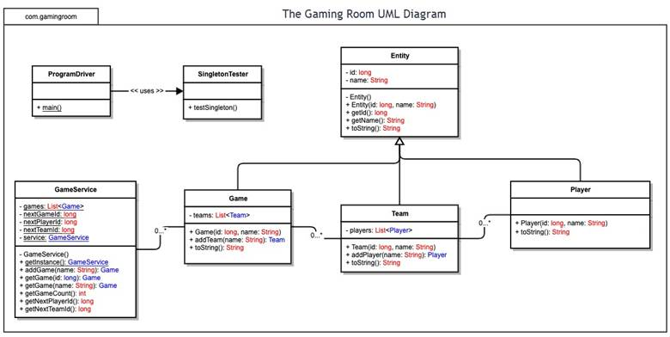

Evaluation

Using your experience to evaluate the characteristics, advantages, and weaknesses of each operating platform (Linux, Mac, and Windows) as well as mobile devices, consider the requirements outlined below and articulate your findings for each. As you complete the table, keep in mind your client’s requirements and look at the situation holistically, as it all has to work together.

In each cell, remove the bracketed prompt and write your own paragraph response covering the indicated information.

Development Requirements | Mac | Linux | Windows | Mobile Devices
Server Side | Mac can host a web application with web server software. It is a stable platform, but it is not used for web servers as often as Linux. Apple computers can also be more expensive, so using Macs for a large server setup could cost more. | Linux is a good option for hosting a web application. It works with web servers like Apache and Nginx and is commonly used for websites. Many Linux versions are free, which can save money on licensing. One downside is that the team may need experience using Linux and command-line tools. | Windows can host the game using Windows Server and IIS. It is easy to use for developers who already know Windows and Microsoft tools. The main weakness is cost because Windows Server normally requires a paid license. It can still be a reliable choice for hosting the game. | Mobile devices would not be a good choice for hosting the main game server. Phones and tablets do not have the same resources as a server and are not meant to handle thousands of players. They would work better as devices that connect to the game server.
Client Side | Mac players can use the game in browsers such as Safari or Chrome. Since the game will use HTML, CSS, and JavaScript, a separate Mac app should not be needed. The developers would still need to test the game on Mac browsers to make sure everything displays and works correctly. | Linux players can access the game through a web browser such as Chrome or Firefox. The developers should test the website on Linux to make sure the layout and game features work correctly. Using a browser-based game saves time because a separate Linux version does not have to be created. | Windows players can use browsers such as Edge, Chrome, or Firefox. The development team would need to test the game in the different browsers and screen sizes. Since it is web based, most of the same code can be used instead of making a special Windows version. | Mobile devices need more testing because Android and iOS phones have different screen sizes and browsers. The website should use responsive HTML and CSS so it fits smaller screens and works with touch controls. Testing on both Android and iPhone will take extra time, but separate mobile apps are not required.
Development Tools | Developers can use Java for the server side and HTML, CSS, and JavaScript for the website. Eclipse, IntelliJ, or Visual Studio Code can be used on Mac. Many of these tools have free versions, so the development cost can stay fairly low. | Linux supports Java, HTML, CSS, and JavaScript. Developers can use Eclipse, IntelliJ, Visual Studio Code, Git, and command-line tools. A lot of Linux tools are free. The team would mainly need someone who is comfortable working with Linux servers. | Windows also supports Java and web languages such as HTML, CSS, and JavaScript. Eclipse, IntelliJ, and Visual Studio Code can be used. Some software and Windows licenses may cost money, but the same development team could still work on the Windows version. | For mobile devices, the team can still use HTML, CSS, and JavaScript because the game runs in a browser. Android Studio can help test Android devices, and Xcode can be used for iOS testing. The developers need to understand responsive design and mobile testing, but separate Android and iOS teams should not be needed.

Recommendations

Analyze the characteristics of and techniques specific to various systems architectures and make a recommendation to The Gaming Room. Specifically, address the following:

1. Operating Platform: <Recommend an appropriate operating platform that will allow The Gaming Room to expand Draw It or Lose It to other computing environments.>

2. Operating Systems Architectures: <Describe the details of the chosen operating platform architectures.>

3. Storage Management: <Identify an appropriate storage management system to be used with the recommended operating platform.>

4. Memory Management: <Explain how the recommended operating platform uses memory management techniques for the Draw It or Lose It software.>

5. Distributed Systems and Networks: <Knowing that the client would like Draw It or Lose It to communicate between various platforms, explain how this may be accomplished with distributed software and the network that connects the devices. Consider the dependencies between the components within the distributed systems and networks (connectivity, outages, and so on).>

6. Security: <Security is a must-have for the client. Explain how to protect user information on and between various platforms. Consider the user protection and security capabilities of the recommended operating platform.>

